**Jenkins Task-2**

**Task Description:**

Create a simple script file and push it to repo. Create a project in Jenkins connected to your GitHub repository. When a commit is made to your repo, automatically build must get triggered from Jenkins and the output must be shared to me via email.

Create a simple script file and push it to repo.

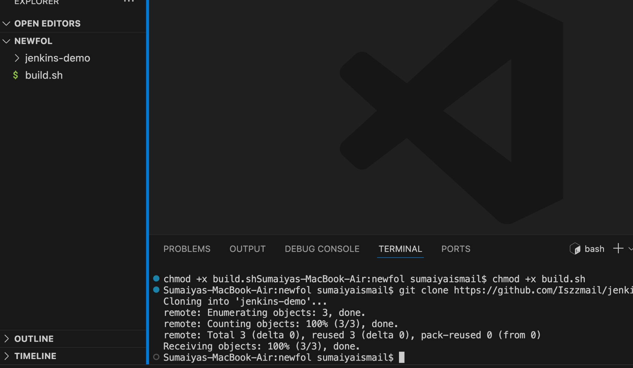

connecting gmail in jenkins

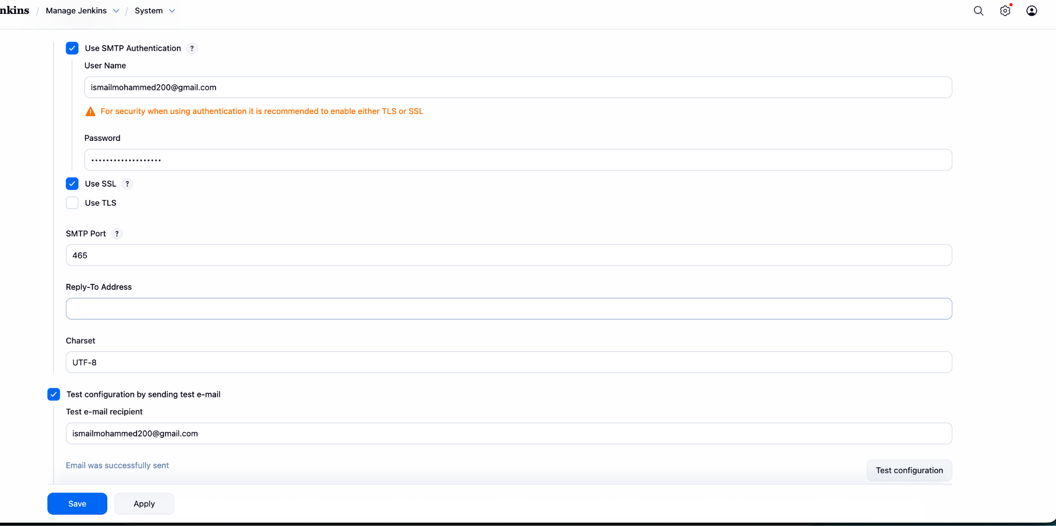

**Successfully got the test email**

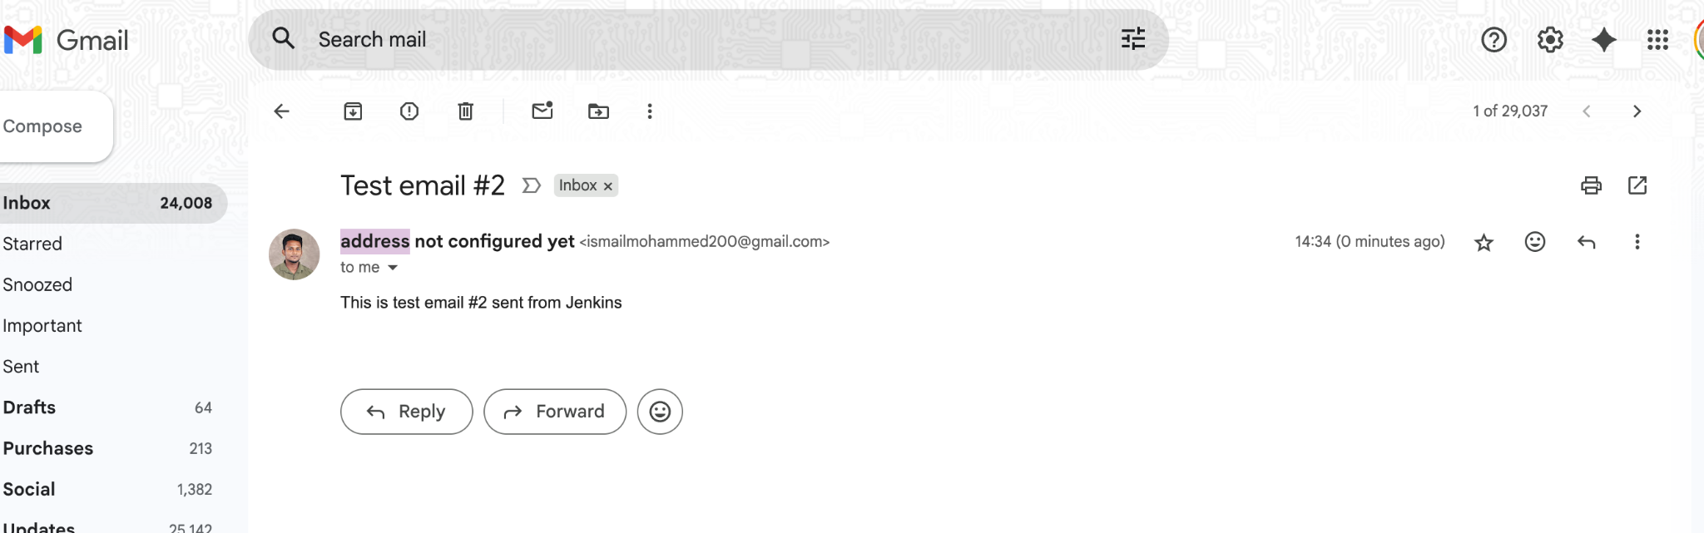

**Setting up github**

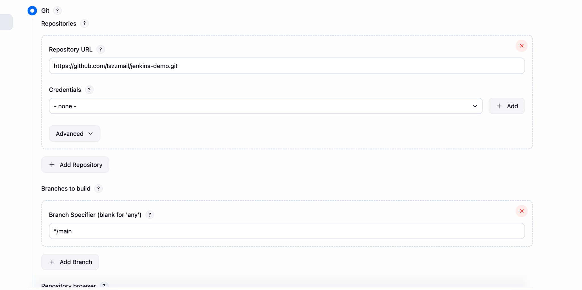

**setting up github webhooks**

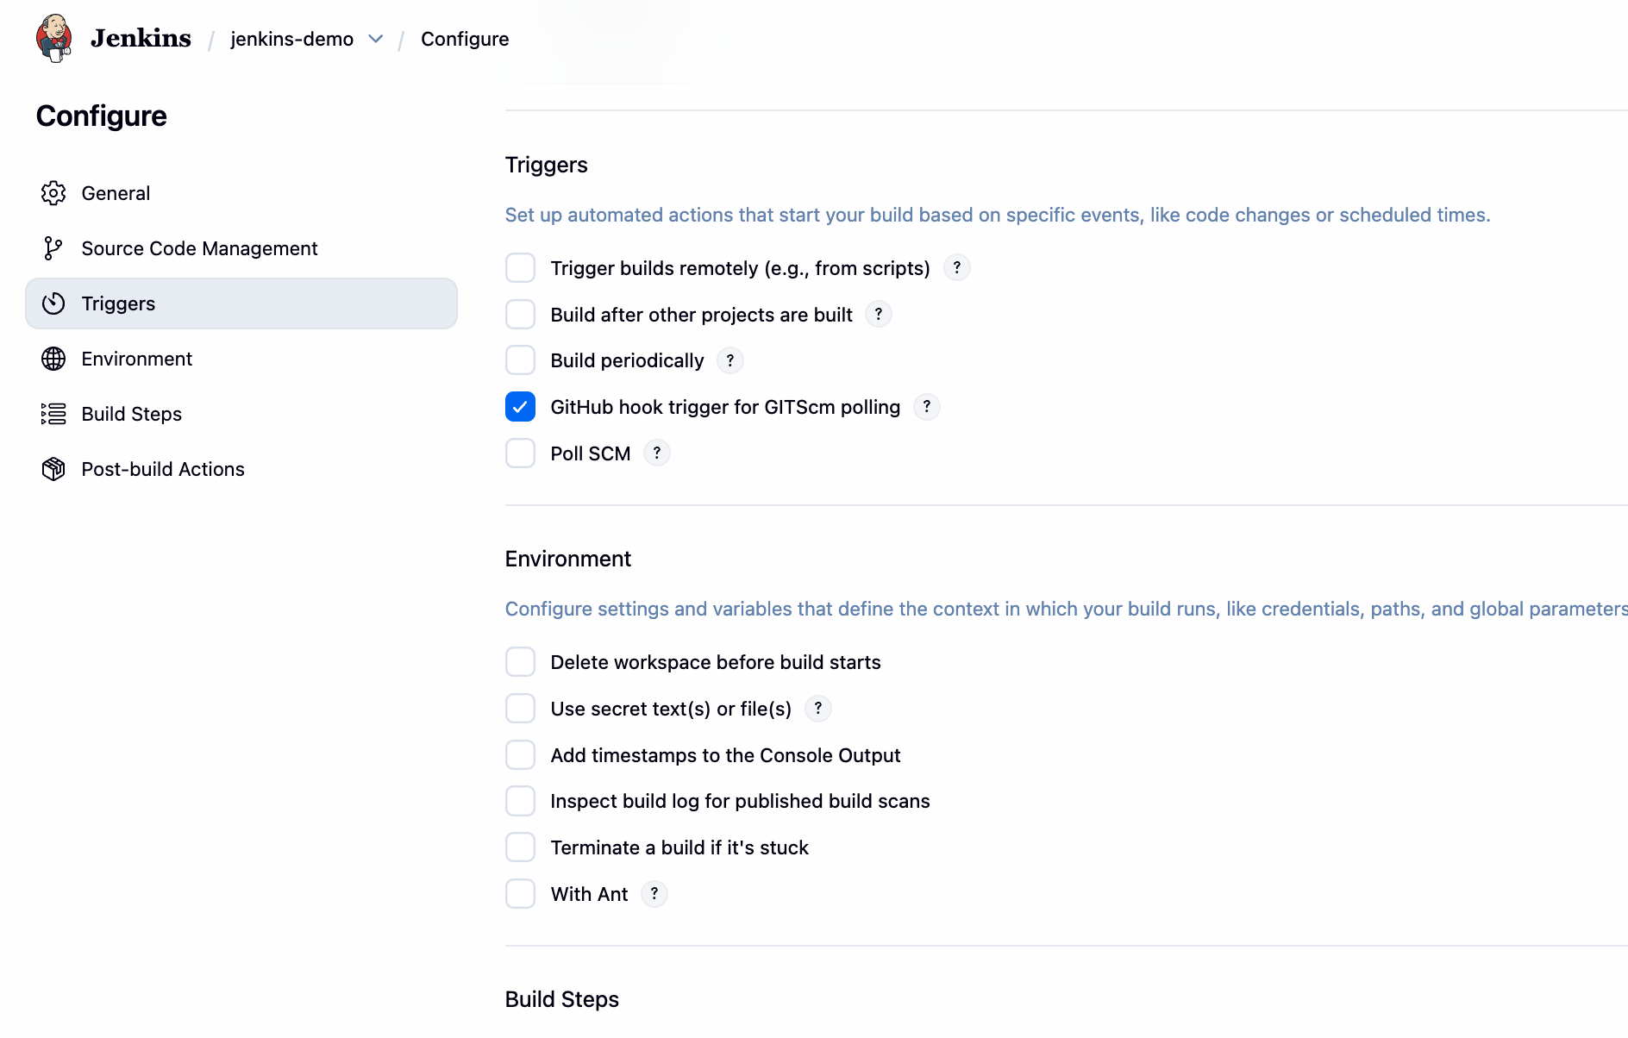

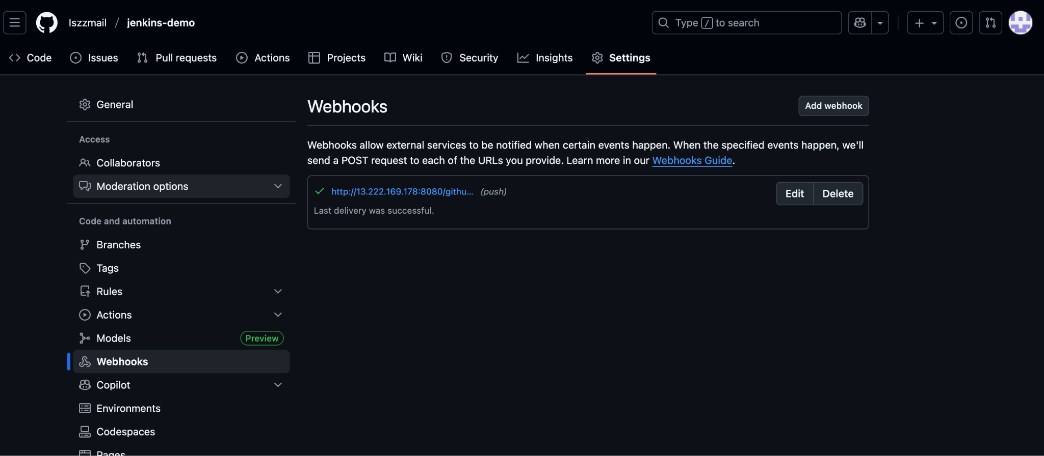

**Making the change in build file**

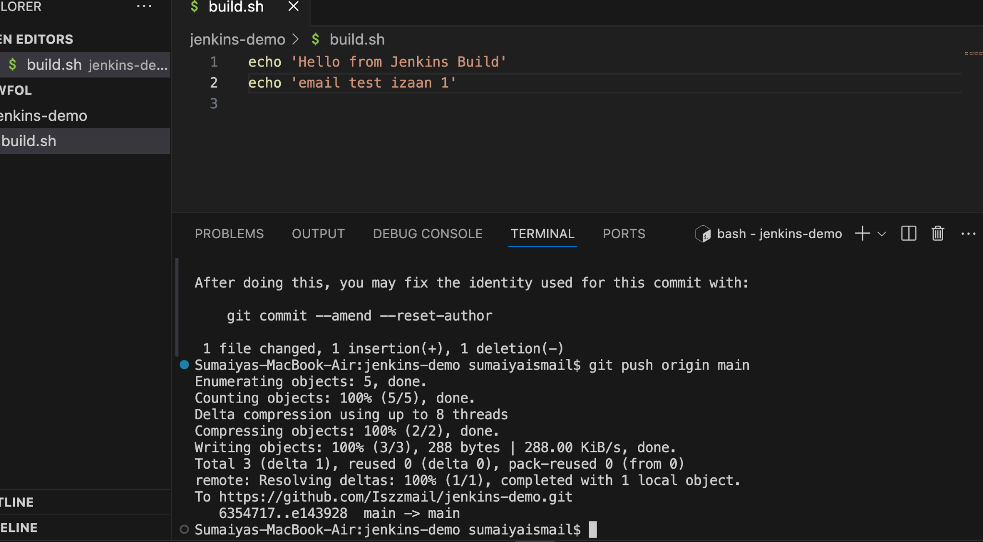

**Build is successfull**

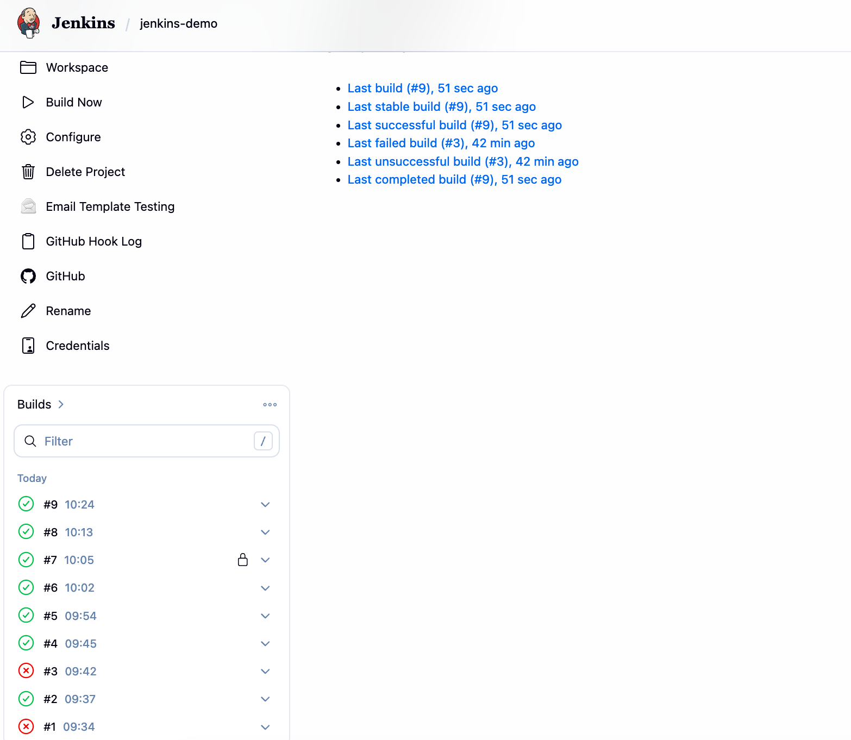

**Received email notification**



